


PERTANDINGAN WORLDSKILLS MALAYSIA KATEGORI BELIA (WSMB) TAHUN 2025

IT SOFTWARE SOLUTION FOR BUSINESS

SOALAN PRAKTIKAL –
PANGKALAN DATA

PERINGKAT PRA-KELAYAKAN

MASA : 2 JAM

NAMA: _______________________________________

No. KP: _______________________________________

JABATAN PEMBANGUNAN KEMAHIRAN
KEMENTERIAN SUMBER MANUSIA

Description of Project and Tasks - Database

This project consists of two parts, part 1 is Entity-Relationship-Diagram (ERD), and part 2 is Structured Query Language (SQL). In Part 1, you are given a case study. Based on the case study, you are required to draw an ERD. SQL is required for Part 2. You are given tables with some data. Based on the output given, you are required to write the SQL so that the output can be displayed as required by the questions.

Part | Topic | Marks
1 | Entity-Relationship-Diagram (ERD) | 100
2 | Structured Query Language (SQL) | 100
Total |  | 200

Prior to the start of the competition, participants will be given 15 minutes to understand the question and the marking scheme. Participants will be given the opportunity to ask the judges any questions that arise or the marking scheme.

Note: If you are in doubt about any other tools or database you wish to use, check with the judges before you start.

PART 1

InstructionS

- You must complete this question individually.
- You are required to construct or draw a complete Entity Relationship Diagram (ERD) for the given case study using Crow’s Foot notation or other notation that you are familiar. You may add any necessary components to support your ERD. You must use any related software, such as Draw.io.

- Your ERD must have the following components:

Component
Entities
Primary Key attributes
Foreign Key attributes
Other Attributes
Relationship Lines (solid line and/or dashed line) including their name
Relationship Connectivity
Relationship Participation (Optional or/and Mandatory)
Cardinality

CASE STUDY

The Director of the "University Aman Jaya Security Department" requires the design of a database to assist with the administration of traffic summons. The related operations are as follows:
- A staff member may register none or multiple vehicles (up to a maximum of three), and each vehicle is registered under one and only one staff member. Students are not allowed to bring, register, or park their cars anywhere within campus limits. No exemptions are made for students with off-campus jobs.
- There are two types of vehicles that can be registered: cars and motorcycles. All vehicles have a vehicle number, plate number, registration date, brand, model, original color, and road tax expiry date.
- The color of a vehicle may change over time. A vehicle may be recorded in a traffic summon ticket as one color but could appear with a different color in another ticket. The system should allow tracking of the vehicle's color at any given time.
- Each staff member has a staff number, name, identity card number, position, department, official email address, personal email address (if any), office phone number, mobile phone number, driving license number, and driving license expiry date. Not all staff members possess a driving license (some may use public transportation, etc.).
- Each staff member belongs to one and only one department. A department can have one or more staff members. The details stored for each department include department ID, name, location, email, phone number, fax number, official Instagram handle (if any), and official Facebook page (if any).
- Traffic summon tickets are issued to the person (staff member) driving the vehicle. A ticket may include one or multiple offenses. The data stored for each traffic summon ticket includes ticket number, date of offense, time of offense, place of offense, total fine amount (RM), and payment status.
- The data stored for each offense includes offense ID, name, and fine amount (RM). The offenses listed on each ticket are ordered sequentially, starting from 1. This means that the first offense written on a ticket is labeled as offense number 1, the second as offense number 2, and so on.

PART 2

InstructionS

You must construct Structured Query Language (SQL) statements using Microsoft SQL or mySQL database based on the provided user requirements, Entity Relationship Diagram (ERD), and database table data (refer to the appendices).

Marking Scheme for Part 2:

Questions | Marks | Marks Given
Question 1 | 10
Question 2 | 10
Question 3 | 10
Question 4 | 15
Question 5 | 15
Question 6 | 15
Question 7 | 10
Question 8 | 15
Total Marks | 100 / 5 = 20 marks

QUESTION 1 (10 MARKS)

Construct an SQL statement to display all records of zookeepers whose specialized skill contains the word 'Mammals' or whose experience level is either Expert or Beginner. The expected output is as follows:

ZOOKEEPER  ID | NAME | EXPERIENCE  LEVEL | SPECIALISED  SKILL | HABITAT  ID | SUPERVISOR  ID | SUPERVISION  STARTDATE | SUPERVISION  ENDDATE | SUPERVISION  LEVEL
ZK001 | John Smith | Expert | Large Mammals | H001 | - | 1/15/2020 | - | 1
ZK003 | Mike Green | Beginner | Birds | H003 | ZK002 | 6/5/2022 | - | 3
ZK004 | Sarah Jones | Expert | Small Mammals | H004 | - | 2/20/2020 | - | 1
ZK006 | Mark Black | Beginner | Amphibians | H006 | ZK005 | 7/1/2022 | - | 3

QUESTION 2 (10 MARKS)

Construct an SQL statement to display the habitat ID, habitat type, climate, maximum capacity, and status, where the maximum capacity is between 20 and 30, the climate is either Humid or Dry, and the habitat status is Operational. The expected output is as follows:

HABITATID | HABITATTYPE | CLIMATE | MAXIMUMCAPACITY | STATUS
H001 | Savannah | Dry | 30 | Operational
H007 | Tropical Forest | Humid | 25 | Operational

QUESTION 3 (10 MARKS)

Construct an SQL statement to retrieve the total habitat size for each habitat status. Group the output by the status of the habitats and display the total size as TOTAL SIZE. Finally, sort the output in descending order based on the total size. The expected output is as follows:

STATUS | TOTAL SIZE
Operational | 4200
Designated for Future Use | 1200
Under Renovation | 800
Under Maintenance | 600

QUESTION 4 (15 MARKS)

Construct an SQL statement to retrieve the experience levels of zookeepers and the count of zookeepers for each experience level. Only include experience levels that have 2 or more zookeepers in the result. Label the count of zookeepers as TOTALZOOKEEPERS and sort the results in ascending order based on the level of experience. The expected results are as follows:

EXPERIENCELEVEL | TOTALZOOKEEPERS
Beginner | 2
Expert | 2
Intermediate | 3

QUESTION 5 (15 MARKS)

Construct an SQL statement to retrieve details of animals (animal ID, species, and diet), their assigned zookeepers (zookeeper ID and name), and the specific duties of each zookeeper for the animal. Sort the output by animal ID in ascending order. You can use any JOIN technique except for NATURAL JOIN. The expected output is as follows:

ANIMALID | SPECIES | DIET | ZOOKEEPERID | NAME | SPECIFICDUTY
A001 | Lion | Carnivore | ZK001 | John Smith | Feeding, Training
A002 | Elephant | Herbivore | ZK001 | John Smith | Health Monitoring, Feeding
A003 | Giraffe | Herbivore | ZK002 | Alice Brown | Health Monitoring, Feeding
A004 | Penguin | Carnivore | ZK003 | Mike Green | Feeding, Health Monitoring
A005 | Tiger | Carnivore | ZK007 | Peter White | Feeding, Training
A006 | Zebra | Herbivore | ZK005 | Rachel Lee | Training, Feeding
A007 | Kangaroo | Herbivore | ZK003 | Mike Green | Feeding, Enrichment Activities

QUESTION 6 (15 MARKS)

Construct an SQL statement to retrieve all habitats (HABITATID and HABITATTYPE) and the animals living in them (SPECIES and NAME). Include all habitats, even those without any animals. Sort the results by NAME in ascending order. The expected output is as follows:

HABITATID | HABITATTYPE | SPECIES | NAME
H005 | Grassland | Elephant | Dumbo
H005 | Grassland | Zebra | Marty
H005 | Grassland | Giraffe | Melman
H007 | Tropical Forest | Kangaroo | Roo
H001 | Savannah | Tiger | Shere Khan
H001 | Savannah | Lion | Simba
H003 | Arctic | Penguin | Skipper
H008 | Tundra | - | -
H002 | Rainforest | - | -
H004 | Desert | - | -
H006 | Wetlands | - | -

QUESTION 7 (10 MARKS)

Construct an SQL statement to retrieves the list of zookeeper IDs who are assigned to animals. You must use a SET operation to accomplish this. The expected output is as follows:

ZOOKEEPERID
ZK001
ZK002
ZK003
ZK005
ZK007

QUESTION 8 (15 MARKS)

Construct an SQL statement to retrieve the zookeeper id and name of zookeepers who are associated with the zoo vehicle that has the license plate number 'MNO1234'. You must use the nested query technique to achieve this. The expected output is as follows:

ZOOKEEPERID | NAME
ZK004 | Sarah Jones

Appendix - ENTITY RELATIONSHIP DIAGRAM (ERD)

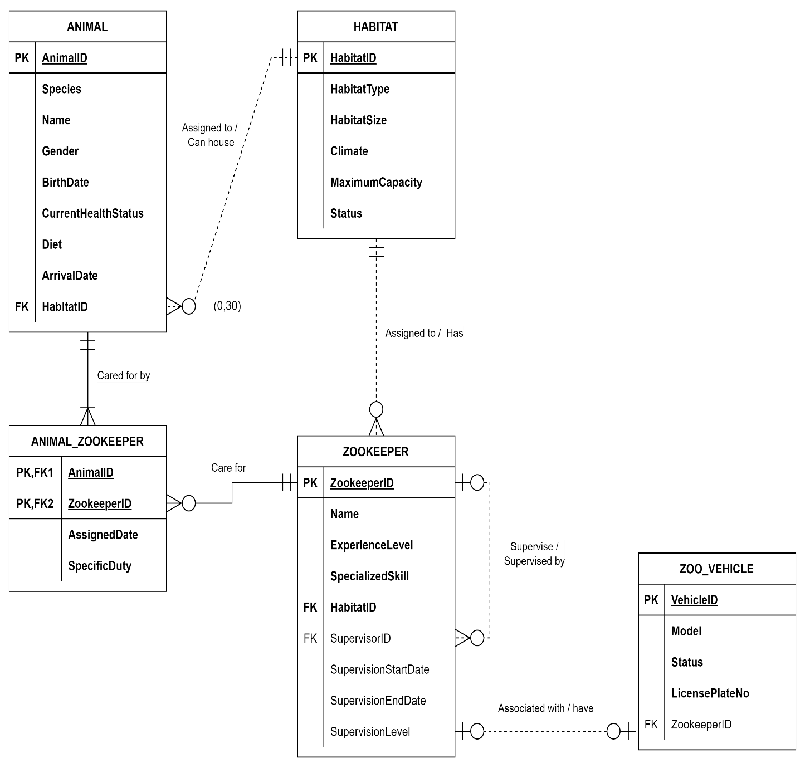

APPENDIX - TABLE DATA

HABITAT table

HABITATID | HABITATTYPE | HABITATSIZE | CLIMATE | MAXIMUMCAPACITY | STATUS
H001 | Savannah | 1000 | Dry | 30 | Operational
H002 | Rainforest | 800 | Humid | 30 | Under Renovation
H003 | Arctic | 500 | Cold | 10 | Operational
H004 | Desert | 1200 | Hot | 30 | Designated for Future Use
H005 | Grassland | 900 | Temperate | 20 | Operational
H006 | Wetlands | 700 | Humid | 15 | Operational
H007 | Tropical Forest | 1100 | Humid | 25 | Operational
H008 | Tundra | 600 | Cold | 20 | Under Maintenance

ANIMAL table

ANIMALID | SPECIES | NAME | GENDER | BIRTHDATE | CURRENT  HEALTHSTATUS | DIET | ARRIVALDATE | HABITATID
A001 | Lion | Simba | Male | 08/14/2015 | Healthy | Carnivore | 02/10/2016 | H001
A002 | Elephant | Dumbo | Male | 05/21/2013 | Injured | Herbivore | 11/05/2014 | H005
A003 | Giraffe | Melman | Male | 07/09/2018 | Healthy | Herbivore | 03/12/2019 | H005
A004 | Penguin | Skipper | Female | 01/23/2020 | Healthy | Carnivore | 06/08/2020 | H003
A005 | Tiger | Shere Khan | Male | 06/25/2014 | Healthy | Carnivore | 09/15/2015 | H001
A006 | Zebra | Marty | Male | 04/16/2017 | Healthy | Herbivore | 02/18/2018 | H005
A007 | Kangaroo | Roo | Female | 11/30/2019 | Healthy | Herbivore | 03/10/2020 | H007

ZOOKEEPER table

ZOOKEEPER  ID | NAME | EXPERIENCE  LEVEL | SPECIALISED  SKILL | HABITAT  ID | SUPERVISOR  ID | SUPERVISION STARTDATE | SUPERVISION ENDDATE | SUPERVISION  LEVEL
ZK001 | John Smith | Expert | Large Mammals | H001 | - | 01/15/2020 | - | 1
ZK002 | Alice Brown | Intermediate | Reptiles | H002 | ZK001 | 03/10/2021 | - | 2
ZK003 | Mike Green | Beginner | Birds | H003 | ZK002 | 06/05/2022 | - | 3
ZK004 | Sarah Jones | Expert | Small Mammals | H004 | - | 02/20/2020 | - | 1
ZK005 | Rachel Lee | Intermediate | Herbivores | H005 | ZK004 | 04/10/2021 | - | 2
ZK006 | Mark Black | Beginner | Amphibians | H006 | ZK005 | 07/01/2022 | - | 3
ZK007 | Peter White | Advanced | Large Carnivores | H007 | ZK001 | 09/15/2020 | - | 2
ZK008 | Laura Grant | Intermediate | Polar Animals | H008 | ZK004 | 05/20/2021 | - | 2

ANIMAL_ ZOOKEEPER table

ANIMALID | ZOOKEEPERID | ASSIGNEDDATE | SPECIFICDUTY
A001 | ZK001 | 01/15/2017 | Feeding, Training
A002 | ZK001 | 03/10/2016 | Health Monitoring, Feeding
A003 | ZK002 | 04/01/2019 | Health Monitoring, Feeding
A004 | ZK003 | 07/10/2020 | Feeding, Health Monitoring
A005 | ZK007 | 10/05/2016 | Feeding, Training
A006 | ZK005 | 03/05/2018 | Training, Feeding
A007 | ZK003 | 04/15/2020 | Feeding, Enrichment Activities

ZOO_VEHICLE table

VEHICLEID | MODEL | STATUS | LICENSEPLATENUMBER | ZOOKEEPERID
V001 | Toyota Hilux | Operational | XYZ1234 | ZK001
V002 | Ford Ranger | Under Maintenance | ABC5678 | -
V003 | Honda CR-V | Operational | DEF9012 | ZK002
V004 | Jeep Wrangler | Operational | GHI3456 | ZK003
V005 | Land Rover | Under Maintenance | JKL6789 | -
V006 | Ford Escape | Operational | MNO1234 | ZK004

